THE PASSIVE VOICE

Complete the sentences with the correct passive form of the verbs in brackets. Use the present simple.

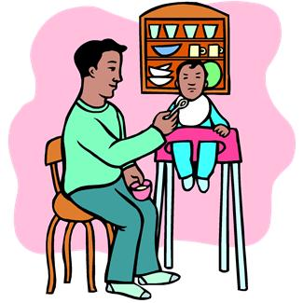 |  |  |  | 
1. The baby are feed (feed) | 2. The phone call answers (answer) by the receptionist. | 3. We serves (serve) by the waitresses. | 4. The cow milks (milk) by the farmer | 5. Fancy dress costumes wears (wear) at Carnival.
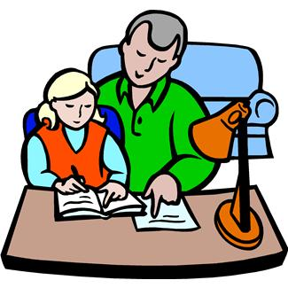 |  | 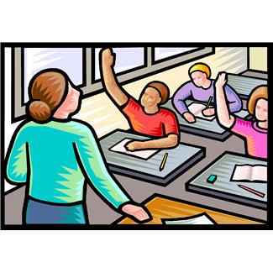 |  | 
6. I are helped (help) by my father. | 7. The dishes are washed .(wash) | 8. Questions asks (ask) to the teacher. | 9. Mother are drived (drive) to work by dad. | 10. The car are repaired (repair) by the mechanic.
 | 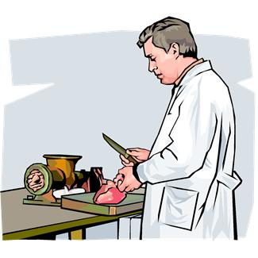 | 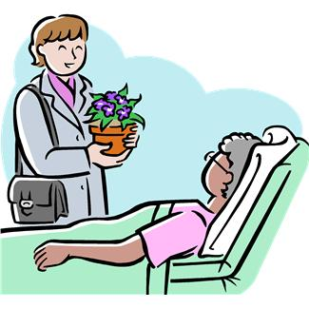 |  | 
11. Letters are typed (type) by the secretary. | 12. Meat are sold (sell) at the butcher’s. | 13. Granny are visited (visit) at hospital. | 14. Coffee are grown (grow) in Colombia. | 15. The trousers are iron (iron).
 | 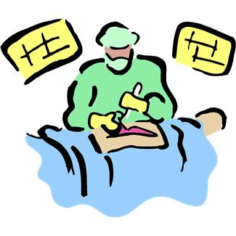 |  |  | 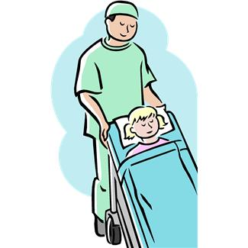
16. Sushi are eaten (eat) in Japan. | 17. The operation are performed (perform) by the surgeon. | 18. A book are borrowed (borrow) from the library. | 19. The problem are explained (explain) by the teacher | 20. The patient are carried (carry) by  The orderly.
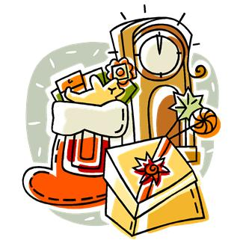 |  | 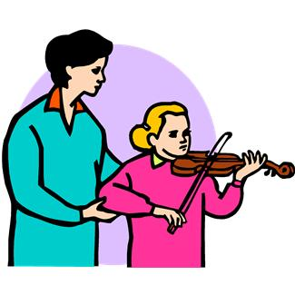 | 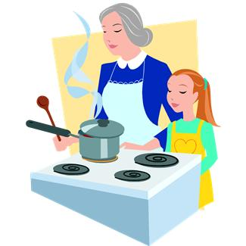 | 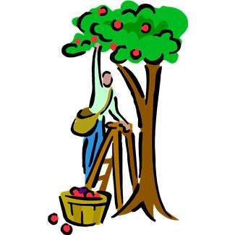
21. Presents are gave (give) at Christmas. | 22 The exam are doing (do) by the student. | 23. The violin is played. (play) by Carol. | 24. Lunch is cooked (cook) by Sally and her grandma. | 25. Apples are picked up (pick up) in summer.

